Mutua Fadhla Mohamed
SM3201434
Okapi-BM25 with pseudo-relevance feedback on OpenAlex API

Introduction
This projects Goal is to test retrieval methods by applying probabilistic IR methods, specifically Okapi BM25, and BM25 with pseudo-relevance feedback assuming top-k retrieved documents are relevant. The experiments are conducted using metadata retrieved from the OpenAlex API, with queries designed to cover both STEM and social science domains.
Through this study, we analyse how probabilistic term weighing influence retrieval effectiveness across different types of documents.

Okapi BM25 is a ranking function derived from the Binary Independence Model (BIM) that estimates the relevance of documents to a given query using term frequency (TF), inverse document frequency (IDF), and document length normalization (dl_{n}). Pseudo-relevance feedback (PR) extends this approach by assuming the top-ranked documents from an initial retrieval are relevant and using their term distributions to expand and reweigh the original query.

Methodology
An initial dataset is obtained by querying the OpenAlex API for scholarly works related to a predefined set of queries spanning STEM, social sciences, and humanities. To reduce the occurrence of missing abstracts, retrieval is restricted to open-access documents using the `open_access.is_oa:true` filter.
For each query, results are retrieved using pagination and parallel requests, and documents are deduplicated globally using OpenAlex work identifiers. Each retrieved document contains the following metadata: ID, title, publication year, concepts, and abstract, where the abstract is provided by OpenAlex in an inverted index format.
The inverted abstract representation is first converted into a human-readable text form by reconstructing the abstract from its positional index. This reconstructed text is stored separately for inspection and verification. The original inverted index representation is also preserved.
The initial collection consists of 46,191 unique documents. Documents with missing or empty abstracts are subsequently removed, resulting in a final corpus of 34,560 documents.
For information retrieval experiments, the abstract inverted index is expanded into a token sequence by repeating each term according to its frequency and normalizing all tokens to lowercase. English stop-words are removed using the NLTK stopword list. Since CSV files do not support native list structures, token lists are serialized into JSON strings before storage.
This processed dataset serves as the input corpus for Okapi BM25 and BM25 with pseudo-relevance feedback experiments.

Okapi BM25 is used as the baseline retrieval method. For each query, BM25 produces an initial ranked list of documents based solely on the original query terms. This ranking serves both as a performance baseline and as the input to the pseudo-relevance feedback mechanism in subsequent experiments. For each unique query, the inverted index of the response is saved so as to expedite future queries and

For pseudo-relevance feedback, the top k documents returned by the initial BM25 ranking are assumed to be relevant. Terms are extracted from these documents and used to expand the original query. The expanded query is then reissued to the BM25 model, producing a new ranking. Different values of k are tested to analyse the impact of feedback depth on retrieval performance.

Retrieval effectiveness is evaluated using Precision@k, Recall@k, Mean Average Precision (MAP) and Mean Average Recall (MAR). Plots were generated for MAP@k and MAR@k across all queries. Other factors such as k1 (which controls the effect multiple appeareances of a term has on the score) and b (penalisation for long documents) are fixed at a constant 1.5 and 0.75 respectively.

Results
Inspection of the initial BM25 rankings indicates that retrieval quality is strongly influenced by the lexical overlap between query terms and the corpus vocabulary. Queries sharing semantically meaningful terms with the indexed documents tend to produce more coherent initial rankings. When the query shares semantically meaningful terms with the indexed documents, BM25 ranks relevant documents effectively. However, as the number of query terms absent from the corpus increases, the model’s ability to accurately rank relevant documents degrades.
When pseudo-relevance feedback is applied, the retrieval process exhibits improved directional stability. By re-weighting terms based on the initially retrieved documents, pseudo-relevance feedback compensates for missing or weakly represented query terms, leading to more coherent rankings even when the original query has limited lexical overlap with the corpus.

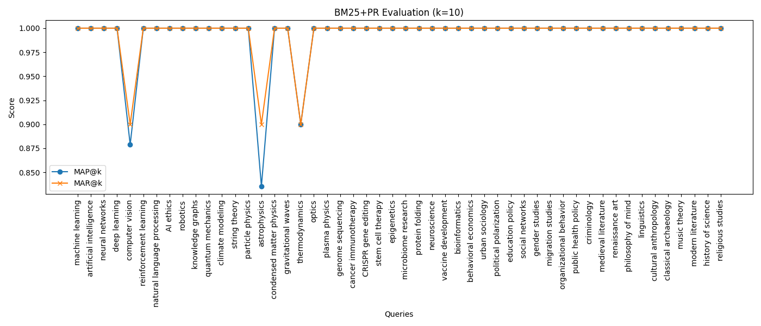
Applying different values of k, using the initial corpus-defining queries, we observe that for the majority of queries both MAP@k and MAR@k remain perfect, even at very small retrieval depths. This indicates that, for these queries, the top-ranked documents retrieved by BM25 with pseudo-relevance feedback are highly consistent and unambiguous, causing the pseudo-relevance feedback process to stabilize after the initial iteration.
A small subset of queries, namely; computer vision, astrophysics, and thermodynamics exhibits a modest decrease in MAP@k and MAR@k at k=10. These queries correspond to broad or interdisciplinary topics, for which relevant documents are distributed across multiple subdomains. Presumably, when expanding to the top-10 results, the ranking may include documents that are topically related but not uniformly relevant, leading to a slight reduction in both precision and recall.
Overall, these findings suggest that pseudo-relevance feedback is highly robust for specific or narrowly focused queries, while its effectiveness is moderately sensitive to topic breadth.

Conclusion
In conclusion, Okapi BM25 with pseudo-relevance feedback demonstrates strong retrieval stability across a diverse set of queries derived from the OpenAlex corpus. For the majority of queries, the pseudo-relevance process converges immediately, yielding perfect MAP@k and MAR@k even at small retrieval depths.
A limited number of broad or interdisciplinary queries exhibit temporary instability at intermediate values of k, highlighting the sensitivity of pseudo-relevance feedback to topic breadth when relevant documents are distributed, presumably, across multiple subdomains. However, this effect diminishes as k increases, indicating robust convergence behaviour.
Overall, these results indicate that pseudo-relevance feedback is highly effective for well-defined queries, and remains directionally robust for broader queries even when lexical relevance is distributed across diverse topics.

